September Newsletter, 2019
False Bay School
False Bay School is a place that encourages personal and global harmony and love of learning in a spirit of joy and respect

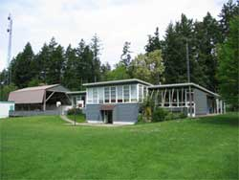

Upcoming Dates

September 27
Design project with Amber

September 30
Orange Shirt Day

October 4
No school (Altered Friday)
October 7th – 10th
Parent/Teacher Conferences
October 14th
Thanksgiving Monday
October 24th – No school
Conferencing Adjustment
October 25th – No school
Provincial Pro-D Day

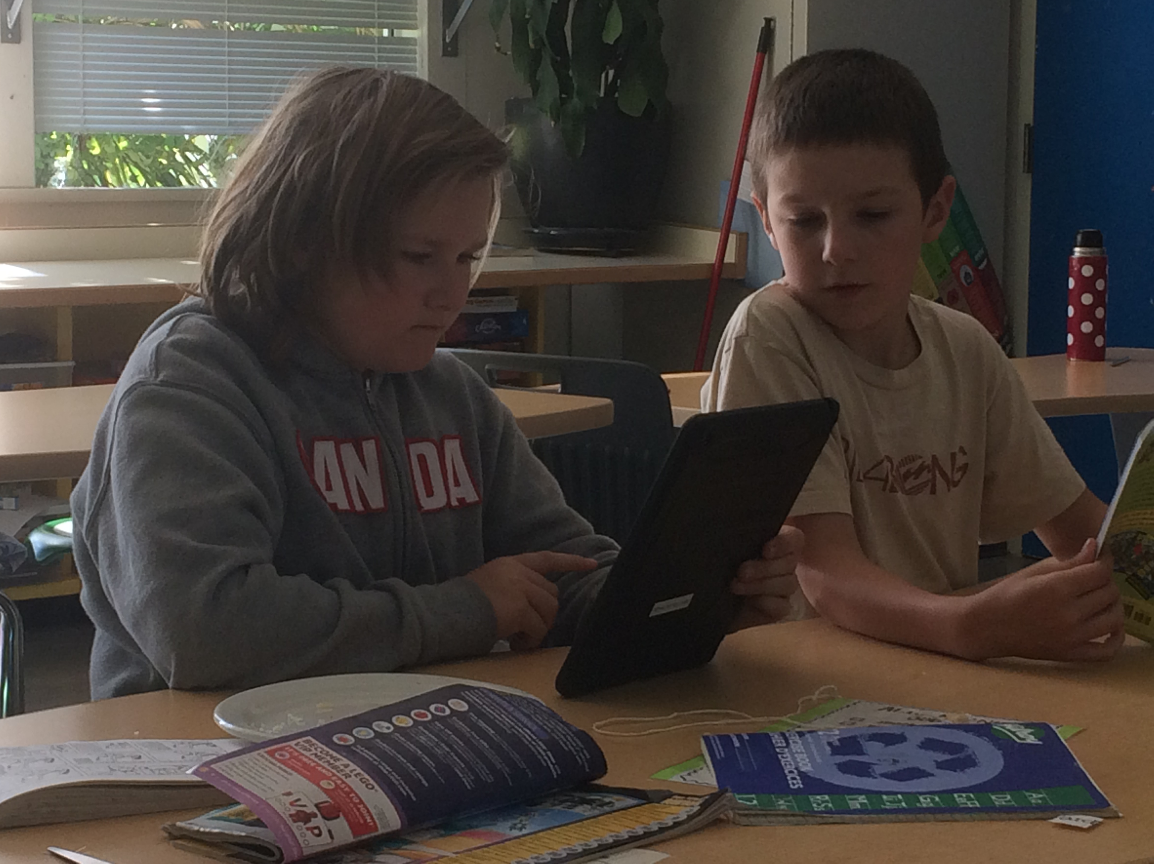

Vice Principal Ms McKinnon’s Message:
“I look forward to Thursday all week knowing I get a break from my otherwise routine work at QBES! I board the ferry each Thursday in anticipation of seeing the children and joining the work Ms Amanda and Ms Anna are doing with the students. Rest assured that the quality of instruction that your kids are receiving at False Bay School is second to none in the broader school district. Ms Amanda and Ms Anna are working hard to meet the learning needs in our multi-age classrooms. Research clearly shows that the primary factor of a child’s success at school is the relationship between student & teacher. Your child has access to two of the best! Already this month we have enjoyed several visitors to our school, including two teaching consultants. We also welcomed Amber today with her toolbox to do a design project. Stay tuned as more folks on “the other side” ask to come over to be part of the exciting work at FBS!
Be sure to book your appointment to conference with your child’s teacher October 7-10. You can call and book through Sylvia (250-333-8813) or drop by to sign up in person. The more connected parents are to their child’s school life, the higher the achievement and overall sense of well-being. The time you invest in your child’s school life will pay dividends later. All of us at FBS look forward to partnering with you this year”
Orange Shirt Day
For Indigenous people, the residential school era was a devastating period in history with long-lasting effects. Every September 30th we observe Orange Shirt Day as we move toward reconciliation. Be sure to look up the story of Phyllis Webstad or watch a short video that explains her story. Check out orangeshirtday.org or watch Phyllis tell her story on youtube! Please remember to dress your child in an Orange Shirt on September 30th to show our support!Uqr01kAk
Dress for Weather Reminder
A reminder goes out to families to anticipate wet and chilly weather conditions. Kids go outside to play several times each day making it necessary to have weather-proof shoes or boots, a sweater or jacket, and warm layers throughout the day. It never hurts to have a change of clothes in the backpack or at school in case of an untimely accident. Plan ahead for comfort!
The kids learning some stretching techniques with Anneliese, one of our awesome volunteers!
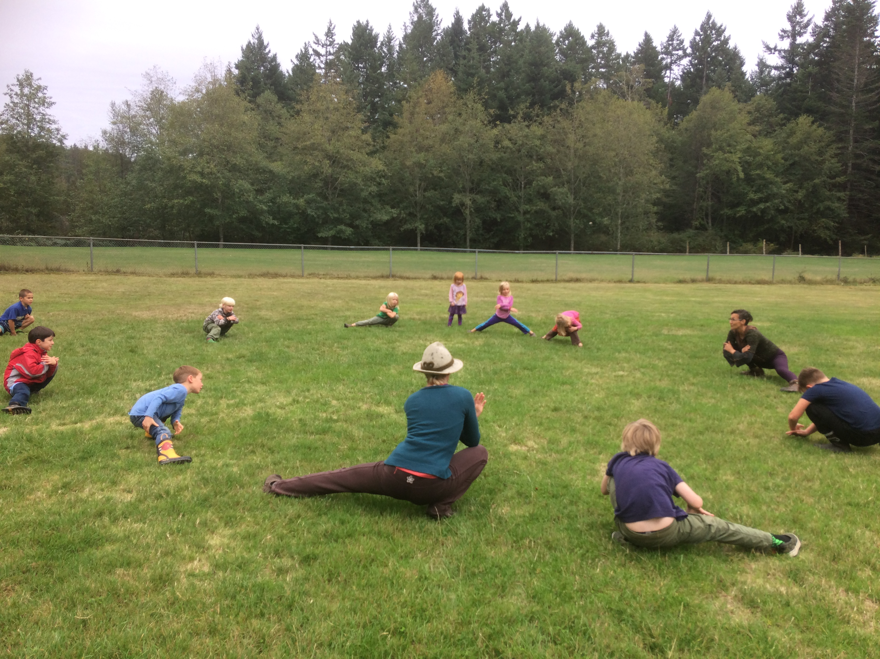
Conflicts are a normal part of the human condition. Childhood is the time we learn effective tools for resolving conflicts with others. Here is what we are teaching at school. Try it at home!
At FBS, We use our
W.I.T.S
- Walk Away
- Ignore
- Talk About It
- Seek Help

Hot Lunch
Hot lunches continue to be provided for FBS students’ whose families choose to participate. Lunch is provided Tuesday, Wednesday and Thursday each week with our fabulous volunteers preparing the meals. Fees are $25 for Kindergarten, $30 for Gr 1-3, $35 for Gr 4 and up. Fees can be paid to Sylvia in the school office or preferably through our easy online pay service called School Cash Online. www.schoolcashonline.com. There’s nothing like a hot meal on a chilly day….Enjoy!

Bus Safety
Safety on the school bus is of great concern. Ask your children if they follow the bus rules...
Q: Did you stay seated and face front today?
A: Yes! Moving while the bus is in motion is super dangerous and distracting for the driver.
Q: Did you speak quietly to your seat partner? Was the noise at a calm, quiet volume?
A: Yes, because we don’t want to distract the driver. Also, people don’t feel good in their stomach, head, or heart when there is excessive noise and chaos. It’s not a good start or end to the school day.

Bus Warning Notes
Drivers may issue a warning note, followed by a bus suspension note if distracting or unruly bus behavior persists. Please discuss as a family the inconveniences your family would face in the event of a bus suspension. It is students’ responsibility to follow bus rules.

Family Accident Reimbursement Plan – Voluntary Insurance

The Board of Education of School District 69 (Qualicum) is offering you the opportunity to voluntarily purchase student accident insurance through iA Financial Group, which is now offering a new comprehensive accident insurance plan with a critical illness component designed for the whole family.
The plan can supplement costs not covered by your provincial health insurance or existing employer extended health and dental plans. Regardless of the size of your family, all eligible family members can be insured under one set monthly rate.
For more information or to apply online, please visit https://www.solutionsinsurance.com/aonbc

